Document

Of

SE323 Term project 1 Presentation  
Due date: - 3 - 2018

By

Chawit Sommana 582115014  
Thanarit Lopetcharat 582115026  
Pattaratorn Sawaisorn 582115039  
Supakorn Kantatewee 582115043

Semester 2 / 2017  
College of Art Media and Technologies

Contents

Topic

Use case Diagram 2

Features of the System 3

User Requirement Specification with Software Requirement Specification 5

Use Case Description 8

Test Plan 20

Test Data 23

Test Script 28

Class Diagram 36

# U**se case Diagram**

# Features of the System

User Requirement Specification

Actor  
Student: student on this system.  
Teacher: Teacher on this system.  
Admin: Administrator of system.

Feature # 1 Login page  
Description: System provide Homepage of Login page for user.  
URS 1: Teacher can Login on Teacher mode.  
URS 2: Student can Login on Teacher mode.  
URS 3: Admin can Login on Admin mode.

Feature # 2 Grading system  
Description: Teacher can give the grading to another student.  
URS 4: Teacher can choose courses list in responsible of teacher.  
URS 5: Teacher can be grading to another student.

Feature # 3 Teaching course list.  
Description: Teacher can see Teaching detail of teaching courses.  
URS 6: Teacher can see teaching courses list on main page.

Feature # 5 Transcript   
Description: Teacher can see result of grade sort by course name of teaching.  
URS 7: Teacher can see a list of students in another course of teaching.  
URS: Teacher can see the grade of another student.

Feature 6 # Logout  
Description: Teacher and Student can Logout from system.  
URS 9: Teacher can Logout to system.  
URS 10: Student can Logout to system.

Feature 7 # List of Enrolled course of student  
Description: Student can see list of enrolled courses.  
URS 11: Student can see List of enrolled courses on main page.

Feature 8 # Delete enrolled course  
Description: Student deleted course from enrolled list.  
URS 12: Student can delete enrolled course from list.

Feature 9 # Add course  
Description: Student can add course for enrolled.  
URS 13: Student can add course from Add course menu.

Feature 10 # Payment   
Description: Student can see Total of tuition fee and detail of courses.  
URS14: Student can see total of tuition fee.  
URS15: Student can see detail of tuition fee of another course.

Feature 11 # Admin can Create course to system.  
Description: Admin can create course into the system.  
URS16: Admin can create course on menu Create course.

Feature 12 # Existed Course.  
Description: Admin can see existed course.  
URS 17: Admin can see detail of existed course on main page of Admin.

User Requirement Specification with Software Requirement Specification   
Feature # 1 Login page  
Description: System provide Homepage of Login page for User   
URS 1: Teacher can Login on Teacher mode

SRS-01: System provide “Teacher Login button”  
SRS-02: System show field Username and Password.  
SRS-03: System provide “Login” button.

URS 2: Student can Login on Teacher mode

SRS-04: System provide “Teacher Login button”  
SRS-05: System show field Username and Password on Teacher mode.  
SRS-06: System provide “Login” button on Teacher mode.

URS 3: Admin can Login on Admin Mode

SRS-07: System show field Username and Password on Admin mode.  
SRS-08: System provide “Login” button on Admin mode.

Feature # 2 Grading system  
Description: Teacher can give the grading to another student  
URS 4: Teacher can choose courses list in responsible of teacher.

SRS-09: System provide “Grading” on menu tab.  
SRS-10: System show teaching course.

URS 5: Teacher can be grading to another student

SRS-11: System provide student list on in this course.  
SRS-12: System have a menu for grading to another system.   
SRS-13: System must have criteria of grade A, B+, B, C+, C+, D+, D, F, W, I.

Feature # 3 Teaching course list.  
Description: Teacher can see Teaching detail of teaching courses.  
URS 6: Teacher can see teaching courses list on main page.

SRS-14: System provide teaching course list on main page of Teacher.  
 SRS-15: Another Course of teaching can link to grading system.

Feature # 5 Transcript   
Description: Teacher can see result of grade sort by course name of teaching  
 SRS-16: System provide “Transcript” on menu bar.  
URS 7: Teacher can see a list of students in another course of teaching.

SRS-17: System show data about teaching course and summary details of another   
 courses.  
 SRR-18: System show List of students.  
URS 8: Teacher can see the grade of other students.

SRS-19: System show data about teaching course and summary details of another   
 courses.  
 SRR-20: System show List of students.  
 SRS-21: System show result of grade base on another student.

Feature 6 # Logout  
Description: Teacher and Student can Logout from system  
URS 9: Teacher can Logout to system.

SRS-22: System provide logout button on Teacher session.  
URS 10: Student can Logout to system.

SRS-23: System provide logout button on Student session.

Feature 7 # List of Enrolled course of student  
Description: Student can see list of enrolled courses  
URS 11: Student can see List of enrolled courses on main page.

SRS-24: System provide List of enrolled courses on main page.

Feature 8 # Delete enrolled course  
Description: Student deleted course from enrolled list  
URS 12: Student can delete enrolled course from list.

SRS-25: System provide List of enrolled courses on main page.  
 SRS-26: System have a “delete” button on another course.

Feature 9 # Add course  
Description: Student can add course for enrolled   
URS 13: Student can add course from Add course menu.

SRS-27: System provide “Add course” on menu bar.  
 SRS-28: System show data of available course for enroll.  
 SRS-29: System have a “add” button on another course.

Feature 10 # Payment   
Description: Student can see Total of tuition fee and detail of course   
URS14: Student can see total of tuition fee.

SRS-30: System provide “payment” on menu bar.  
SRS-31: System show Total of Tuition fee in Baht.

URS15: Student can see detail of tuition fee of another course.

SRS-32: System provide “payment” on menu bar.  
 SRS-33: System show list of enrolled courses and have detail of credit and cost.

Feature 11 # Admin can Create course to system.  
Description: Admin can create course into the system.  
URS16: Admin can create course on menu Create course

SRS-34:System provide “Create course” button on menu bar   
 SRS-35:System provide text box “CourseID”.  
 SRS-36:System provide text box “CourseName”.  
 SRS-37:System provide text box “TeacherName”.  
 SRS-38:System provide text box “Semester”.  
 SRS-39:System provide text box “Academic Year”.  
 SRS-40:System provide text box “Maximum Seat”.  
 SRS-41:System provide text box “Number of Credit”.

Feature 12 # Existed Course  
Description: Admin can see existed course  
URS 17: Admin can see detail of existed course on main page of Admin.  
 SRS-42: System provide data of Existed Course detail.

# Use Case Description

Feature # 1 Login page  
Description: System provide Homepage of Login page for User.   
URS 1: Teacher can Login to the system as a teacher.  
URS 2: Student can Login to the system as a student.  
URS 3: Admin can Login to the system as a Admin

|  |  |  |  |  |  |
| --- | --- | --- | --- | --- | --- |
| Use Case ID | UCD-01 | | | | |
| Use Case Name | User Login | | | | |
| Created By | Thanarit Lopetcharat | | Last Update By | Thanarit Lopetcharat | |
| Date Created | 27-2-2018 | | Last Revision Date | 25-3-2018 | |
| Actors | User | | | | |
| Description | User can login into the system based on character of user. | | | | |
| Trigger | Users clicks Login | | | | |
| Preconditions | -User have an Internet connection.  -User available on login page for student, teacher and Admin.  -User have Username and Password. | | | | |
| Use Case Input Specification | | | | | |
| Input | type | Constraint | | | Example |
| E-mail | String | Set of the string together within English alphabet and Arabic numerical including some special symbol. | | | “willia@cmu.ac.th” |
| Password | String | Set of the string together within English alphabet and Arabic numerical including some special symbol. | | | “123abc” |
| Post conditions | User can access to Registration system. | | | | |
| Normal Flows | User | | System | | |
|  | NF-01: User clicks Login button  NF-03: User input Email and Password  NF-04: User click Login | | NF-02: System provide Login Page.  NF-05: System check input from user  NF-06: System provide Profile page. | | |
| Alternative Flow | NF-05, if system not found Username or password. System cannot provide profile page to user. | | | | |
| Exception Flow | User loss of internet connection. | | | | |
| Assumption | 1. User understands English. | | | | |

Feature # 2 Grading system  
Description: Teacher can give the grading to another student.  
URS 4: Teacher can choose course list in responsible of teacher.  
URS 5: Teacher can be grading to another student.

|  |  |  |  |
| --- | --- | --- | --- |
| Use Case ID | UCD-02 | | |
| Use Case Name | Grading System | | |
| Created By | Thanarit Lopetcharat | Last Update By | Thanarit Lopetcharat |
| Date Created | 27-2-2018 | Last Revision Date | 25-3-2018 |
| Actors | Teacher | | |
| Description | Teacher can give the grading to another student | | |
| Trigger | Teacher click grading menu | | |
| Preconditions | -Teacher have an Internet connection  - User already login to the system as a teacher section. | | |
| Post conditions | User can add Course from course list for enrolled. | | |
| Normal Flows | User | System | |
|  | NF-01: Teacher clicks grading on menu bar.  NF-03: Teacher clicks Course Name which want to be grading.  NF-05: Teacher grading to student. | NF-02: System provide teaching course list. NF-04: System provide the list of students and function to be grading | |
| Alternative Flow | - | | |
| Exception Flow | User loss of internet connection. | | |
| Assumption | 1. User understands English. | | |

Feature # 3 Teaching course list.  
Description: Teacher can see Teaching detail of teaching courses.  
URS 6: Teacher can see teaching courses list on main page.

|  |  |  |  |
| --- | --- | --- | --- |
| Use Case ID | UCD-03 | | |
| Use Case Name | Teacher see the course list. | | |
| Created By | Thanarit Lopetcharat | Last Update By | Thanarit Lopetcharat |
| Date Created | 27-7-2018 | Last Revision Date | 27-7-2018 |
| Actors | Teacher | | |
| Description | Teacher can see a Teaching detail of teaching courses. | | |
| Trigger | Users clicks must open main page of teacher section. | | |
| Preconditions | - User have an Internet connection.  - Teacher already login to the system as a teacher section. | | |
| Post conditions | Teacher can see teaching course. | | |
| Normal Flows | User | System | |
|  | NF-01: teacher clicks button “Main” on menu bar. | NF-02: System provide course list of teaching and detail of any courses. | |
| Alternative Flow | - | | |
| Exception Flow | User loss of internet connection. | | |
| Assumption | 1. User understands English. | | |

Feature # 4 Transcript   
Description: Teacher can see result of grade sort by course name of teaching.  
URS 7: Teacher can see a list of students in another course of teaching.  
URS 8: Teacher can see the grade of other students.

|  |  |  |  |
| --- | --- | --- | --- |
| Use Case ID | UCD-04 | | |
| Use Case Name | Transcript | | |
| Created By | Thanarit Lopetcharat | Last Update By | Thanarit Lopetcharat |
| Date Created | 27-2-2018 | Last Revision Date | 25-3-2018 |
| Actors | Teacher | | |
| Description | Teacher can see the result of grade sort by course name of teaching. | | |
| Trigger | Users clicks Transcript | | |
| Preconditions | -User have an Internet connection.  - User already login to the system as a teacher section. | | |
| Post conditions | User can see grade of student depend on another course. | | |
| Normal Flows | User | System | |
|  | NF-01: User clicks Transcript on menu bar.  NF-03: User clicks Course name on a list. | NF-02: System provide a list of courses.  NF-04: System show a list of students and their grad. | |
| Alternative Flow | - | | |
| Exception Flow | User loss of internet connection. | | |
| Assumption | 1. User understands English. | | |

Feature 5 # Logout  
Description: Teacher and Student can Logout from system.  
URS 9: Teacher can Logout to system.  
URS 10: Student can Logout to system.  
URS 11: Admin can Logout to system.

|  |  |  |  |  |  |
| --- | --- | --- | --- | --- | --- |
| Use Case ID | UCD-05 | | | | |
| Use Case Name | User Logout | | | | |
| Created By | Thanarit Lopetcharat | | Last Update By | Thanarit Lopetcharat | |
| Date Created | 27-2-2018 | | Last Revision Date | 25-3-2018 | |
| Actors | User | | | | |
| Description | User can logout into the system based on character of user | | | | |
| Trigger | Users using this system. | | | | |
| Preconditions | - User have an Internet connection.  - User already login to the system as a teacher section. | | | | |
| Use Case Input Specification | | | | | |
| Input | type | Constraint | | | Example |
| - | - | - | | | - |
| - | - | - | | | - |
| Post conditions | User can logout to Registration system. | | | | |
| Normal Flows | User | | System | | |
|  | NF-01: User clicks Logout | | NF-02: System Logout from system. | | |
| Alternative Flow | - | | | | |
| Exception Flow | User loss of internet connection. | | | | |
| Assumption | 1. User understands English. | | | | |

Feature 6 # List of Enrolled course of student  
Description: Student can see list of enrolled courses.  
URS 12: Student can see List of enrolled courses on main page.

|  |  |  |  |
| --- | --- | --- | --- |
| Use Case ID | UCD-06 | | |
| Use Case Name | List of enrolled courses of student. | | |
| Created By | Thanarit Lopetcharat | Last Update By | Thanarit Lopetcharat |
| Date Created | 27-2-2018 | Last Revision Date | 25-3-2018 |
| Actors | Student | | |
| Description | Student can see list of enrolled courses. | | |
| Trigger | Student can Login into this system. | | |
| Preconditions | - User have an Internet connection.  - User already login to the system as a student section. | | |
| Post conditions | Student can see Enrolled course. | | |
| Normal Flows | User | System | |
|  | NF-01: student click button “Main” on menu bar. | NF-02: system show enrolled course. | |
| Alternative Flow | - | | |
| Exception Flow | User loss of internet connection. | | |
| Assumption | 1. User understands English. | | |

Feature 7 # Delete enrolled course  
Description: Student deleted course from enrolled list.  
URS 13: Student can delete enrolled course from list.

|  |  |  |  |
| --- | --- | --- | --- |
| Use Case ID | UCD-07 | | |
| Use Case Name | Deleted enrolled course | | |
| Created By | Thanarit Lopetcharat | Last Update By | Thanarit Lopetcharat |
| Date Created | 27-2-2018 | Last Revision Date | 25-3-2018 |
| Actors | Student | | |
| Description | Student deleted course from enrolled list. | | |
| Trigger | Student can Login into this system. | | |
| Preconditions | - User have an Internet connection.  - User already login to the system as a student section. | | |
| Post conditions | Student can see delete enrolled course from list. | | |
| Normal Flows | User | System | |
|  | NF-01: student click button “Main” on menu bar. NF-03: Student click delete. | NF-02: system show enrolled course  NF-04: System delete course from enrolled list. | |
| Alternative Flow | - | | |
| Exception Flow | User loss of internet connection. | | |
| Assumption | 1. User understands English. | | |

Feature 8 # Add course  
Description: Student can add course for enrolled.  
URS 14: Student can add course from Add course menu.

|  |  |  |  |
| --- | --- | --- | --- |
| Use Case ID | UCD-08 | | |
| Use Case Name | Add course | | |
| Created By | Thanarit Lopetcharat | Last Update By | Thanarit Lopetcharat |
| Date Created | 27-2-2018 | Last Revision Date | 25-3-2018 |
| Actors | Student | | |
| Description | Student can add course for enrolled. | | |
| Trigger | Student can Login into this system. | | |
| Preconditions | - User have an Internet connection.  - User already login to the system as a student section. | | |
| Post conditions | Student can see add course. | | |
| Normal Flows | User | System | |
|  | NF-01: student click button “Add course” on menu bar.  NF-03: Student click Add. | NF-02: system show available course details for enrolling. NF-04: System provide enrolling the course to student and save into system. | |
| Alternative Flow | - | | |
| Exception Flow | User loss of internet connection. | | |
| Assumption | 1. User understands English. | | |

Feature 9 # Payment   
Description: Student can see Total of tuition fee and detail of course   
URS15: Student can see total of tuition fee  
URS16: Student can see detail of tuition fee of another course

|  |  |  |  |
| --- | --- | --- | --- |
| Use Case ID | UCD-09 | | |
| Use Case Name | Payment | | |
| Created By | Thanarit Lopetcharat | Last Update By | Thanarit Lopetcharat |
| Date Created | 27-2-2018 | Last Revision Date | 25-3-2018 |
| Actors | Student | | |
| Description | Student can see Total of tuition fee and detail of course. | | |
| Trigger | Student can Login into this system. | | |
| Preconditions | - User have an Internet connection.  - User already login to the system as a student section. | | |
| Post conditions | Student can see payment details. | | |
| Normal Flows | User | System | |
|  | NF-01: student click button “Payment” on menu bar. | NF-02: system show detail of Total payment and total of tuition fee in Baht. | |
| Alternative Flow | - | | |
| Exception Flow | User loss of internet connection. | | |
| Assumption | 1. User understands English. | | |

Feature 10 # Admin can Create course to system.  
Description: Admin can create course into the system.  
URS17: Admin can create course on menu Create course.

|  |  |  |  |  |  |
| --- | --- | --- | --- | --- | --- |
| Use Case ID | UCD-10 | | | | |
| Use Case Name | Create course to system | | | | |
| Created By | Thanarit Lopetcharat | | Last Update By | Thanarit Lopetcharat | |
| Date Created | 27-2-2018 | | Last Revision Date | 25-3-2018 | |
| Actors | Admin | | | | |
| Description | Admin can create course into the system. | | | | |
| Trigger | Admin can Login into this system. | | | | |
| Preconditions | - User have an Internet connection.  - User already login to the system as a admin section. | | | | |
| Use Case Input Specification | | | | | |
| Input | type | Constraint | | | Example |
| CourseID | Int | Set of integer numbers. | | | 953211 |
| CourseName | String | Set of the string together within English alphabet. | | | Software maintenance |
| TeacherName | String | Set of the string together within English alphabet and symbol. | | | Dr. Jessada |
| Semester | Int | Set of integer number. | | | 1 |
| AcademicYear | Date | Se of date. | | | 1996 |
| MaximumSeat | Int | Set of integer number. | | | 50 |
| NumberOfcredit | Int | Set of integer number. | | | 3 |
| Post conditions | User can logout to Registration system. | | | | |
| Normal Flows | User | | System | | |
|  | NF-01: Admin clicks button “Create Course”.  NF-03: Admin input the detail of a course.  NF-04: Click Create course | | NF-02: System provide formation for create a course.    NF-05: System will create course and save into the system. | | |
| Alternative Flow | - | | | | |
| Exception Flow | User loss of internet connection. | | | | |
| Assumption | 1. User understands English. | | | | |

Feature 11 # Existed Course.  
Description: Admin can see existed courses.  
URS 18: Admin can see the detail of existed course on the main page of Admin.

|  |  |  |  |
| --- | --- | --- | --- |
| Use Case ID | UCD-11 | | |
| Use Case Name | Existed Course | | |
| Created By | Thanarit Lopetcharat | Last Update By | Thanarit Lopetcharat |
| Date Created | 27-2-2018 | Last Revision Date | 25-3-2018 |
| Actors | Admin | | |
| Description | Admin can see existed course. | | |
| Trigger | Admin can Login into this system. | | |
| Preconditions | - User have an Internet connection.  - User already login to the system as a admin section. | | |
| Post conditions | Admin can see existed list of courses. | | |
| Normal Flows | User | System | |
|  | NF-01: Admin click button “Main” on menu bar. | NF-02: System provide list of the existed courses and detail. | |
| Alternative Flow | - | | |
| Exception Flow | User loss of internet connection. | | |
| Assumption | 1. User understands English. | | |

# Test Plan

Introduction

The test plan is to describe the scope, approach, resource and schedule of all testing activities of the project Registration System.

The plan identifies the items to be tested, the features to be tested, the type of testing to be performed, the resource and schedule required to complete testing and the risk associated with the plan.

Team Member

|  |  |
| --- | --- |
| ID | Name |
| 582115026 | Thanarit Lopetcharat |
| 582115014 | Chawit Sommana |
| 582115039 | Pattaratorn Sawaisorn |
| 582115043 | Supakorn Kantatewee |

1 Test Strategy

1.1 Scope of Testing

1.1.1 Feature to be tested

All the feature of website Registration System which were defined in software requirement specification are needing to be tested.

|  |  |  |
| --- | --- | --- |
| Module Name | Applicable Roles | Description |
| Login | Teacher, Student, Admin | Teacher,Student,Admin: can to login to the system by the valid  e-mail and password that they use to register. |
| Grading | Teacher | Teacher: can grade the students whose enrolled in their course. |
| Teaching course list | Teacher | Teacher: can see all of their teaching course’s list. |
| Transcript | Teacher | Teacher: can view course’s GPA and student’s grade of each courses. |
| Logout | Teacher, Student, Admin | Teacher, Student, Admin: can logout of the system. |
| List of enrolled courses | Student | Student: can view their enrolled courses. |
| Delete enrolled course | Student | Student: can remove their enrolled course. |
| Add course | Student | Student: can enroll the course. |
| Payment | Student | Student: can view the total amount of their tuition fee. |
| Create course | Admin | Admin: can create the course. |
| List of existed courses. | Admin | Admin: can view all of the existed course. |

1.1.2 Feature not to be tested

This feature is not to be tested because it is not included in the software requirement specification.

- User Interfaces

1.2 Test Type

- System Testing: Conducted on a complete system to evaluate the system’s compliance with its specified requirements.

1.3 Risk

|  |  |
| --- | --- |
| Risk | Mitigation |
| Team member lack the required skills for website testing. | Do the research to skill up the team members. |
| A lack of cooperation among team member. | Encourage team member to do the communication and inspire them to greater effort. |
| Project schedule is too tight, it’s hard to complete this project on tine. | Set Test Priority for each of the test activity. |

1.4 Test Logistics

1.4.1 Who will test?

The project will use insource members as the tester.

1.4.2 When will test occur?

The tester will start the test execution when the software is available for testing

2 Test Objective

The test objectives are to verify the functionality of website Registration System. The project should focus on testing the Registration System’s operation such as Create the course, Add the course, show transcript, Grading, etc. to guarantee all these operations can work normally.

3 Test Criteria

3.1 Suspension Criteria

If the team member report that there are 40% of test cases failed, suspend testing until the development team fixes all the failed cases.

3.2 Exit Criteria

The criteria that denote a successful completion of the test phase.

- Run rate is mandatory to be 100%

- Pass rate is over 80%

4. Resource Planning

4.1 System Resource

|  |  |  |
| --- | --- | --- |
| No. | Resource | Description |
| 1. | Katalon | An automated software testing solution. |
| 2. | Computer | At least 1 computer that can run chrome or firefox. |

4.2 Human Resource

|  |  |  |
| --- | --- | --- |
| No. | Member | Tasks |
| 1. | Tester | Execute the tests, Report the defects. |

# Test Data

Test Data Feature#1 Login page

|  |  |  |  |  |  |  |
| --- | --- | --- | --- | --- | --- | --- |
| Test data: Feature # 1 Login page_01 | | | | Executed by: PATTARATORN SAWAISORN | | |
| Short Description: Test the system response when student login to the system. | | | | Date: 3/27/2018 | | |
|  | | | | | | |
| No. | E-mail | Username | Expected System Response | | Actual System Response | Pass/  Fail |
| 1. | Pattaratorn_s@cmu.ac.th | XXXXXXXX | The system provides a Student section page. | | The system provides a Student section page. | Pass |
| 2. | Thanarit_l@cmu.ac.th | XXXXXXXX | The system provides a Student section page. | | The system provides a Student section page. | Pass |
| 3. | Chawittt_S@cm.ac.tu | XXXXXXXX | The system not provides a Student section page and prompt the error message. | | The system provides a Student section page. | Fail |
| 4. | Ia.urn@outlook.com | XXXXXXXX | The system not provides a Student section page and prompt the error message. | | The system provides a Student section page. | Fail |

|  |  |  |  |  |  |  |
| --- | --- | --- | --- | --- | --- | --- |
| Test data: Feature # 1 Login page_02 | | | | Executed by: PATTARATORN SAWAISORN | | |
| Short Description: Test the system response when teacher login to the system. | | | | Date: 3/27/2018 | | |
|  | | | | | | |
| No. | E-mail | Username | Expected System Response | | Actual System Response | Pass/  Fail |
| 1. | Pattama_L@cmu.ac.th | XXXXXXXX | The system provides a Student section page. | | The system provides a Student section page. | Pass |
| 2. | Chartchai_D@cmu.ac.th | XXXXXXXX | The system provides a Student section page. | | The system provides a Student section page. | Pass |
| 3. | Kittitouch | XXXXXXXX | The system not provides a Student section page and prompt the error message. | | The system provides a Student section page. | Fail |
| 4. | Kittitouch_S@gmail.com | XXXXXXXX | The system not provides a Student section page and prompt the error message. | | The system provides a Student section page. | Fail |

Test Data Feature#2 Grading system

|  |  |  |  |  |  |
| --- | --- | --- | --- | --- | --- |
| Test data: Feature # 2 Grading system | | | Executed by: PATTARATORN SAWAISORN | | |
| Short Description: Test the function of Grading part. | | | Date: 3/27/2018 | | |
|  | | | | | |
| No. | Action | Expected System Response | Actual System Response | Pass/Fail | Comment |
| 1. | Teacher select grad A to student. | The system provides a Grad A on a list | The system provides a Grad A on a list | Pass |  |
| 2. | Teacher select grad D to student. | The system provides a Grad D on a list | The system provides a Grad D on a list | Pass |  |
| 3. | Teacher select grad F to student. | The system provides a Grad F on a list | The system provides a Grad F on a list | Pass |  |

Test Data Feature # 3 Teaching course list.

|  |  |  |  |  |  |
| --- | --- | --- | --- | --- | --- |
| Test data: Feature # 3 Teaching course list. | | | Executed by: PATTARATORN SAWAISORN | | |
| Short Description: Test the function to show the teaching courses. | | | Date: 3/27/2018 | | |
|  | | | | | |
| No. | Action | Expected System Response | Actual System Response | Pass/Fail | Comment |
| 1. | teacher clicks button “Main” on menu bar. | The system provides course list of teaching and detail of any courses. | The system provides course list of teaching and detail of any courses. | Pass |  |

Test Data Feature # 4 Transcript

|  |  |  |  |  |  |
| --- | --- | --- | --- | --- | --- |
| Test data: Feature # 4 Transcript | | | Executed by: PATTARATORN SAWAISORN | | |
| Short Description: Test the function to show the transcript of any student. | | | Date: 3/27/2018 | | |
|  | | | | | |
| No. | Action | Expected System Response | Actual System Response | Pass/Fail | Comment |
| 1. | Teacher clicks Modern E-sport subject. | The system provides a list of students and their grad. | The system provides a list of students and their grad. | Pass |  |
| 2. | Teacher clicks All of Nothing subject. | The system provides a list of students and their grad. | The system provides a list of students and their grad. | Pass |  |

Test Data Feature 5 # Logout

|  |  |  |  |  |  |
| --- | --- | --- | --- | --- | --- |
| Test data: Feature 5 # Logout | | | Executed by: PATTARATORN SAWAISORN | | |
| Short Description: Test the function of Logout when user want to log out the system. | | | Date: 3/27/2018 | | |
|  | | | | | |
| No. | Action | Expected System Response | Actual System Response | Pass/Fail | Comment |
| 1. | Teacher clicks button “Log out” | The system logs out the system. | The system logs out the system. | Pass |  |
| 2. | Student clicks button “Log out” | The system logs out the system. | The system logs out the system. | Pass |  |

Test data Feature 6 # List of Enrolled course of student

|  |  |  |  |  |  |
| --- | --- | --- | --- | --- | --- |
| Test data: Feature 6 # List of Enrolled course of student | | | Executed by: PATTARATORN SAWAISORN | | |
| Short Description: Test the function to show the enrolled course of student. | | | Date: 3/27/2018 | | |
|  | | | | | |
| No. | Action | Expected System Response | Actual System Response | Pass/Fail | Comment |
| 1. | Student click button “Main” on menu bar. | The system shows an enrolled course. | The system shows an enrolled course. | Pass |  |

Test Data Feature 7 # Delete enrolled course

|  |  |  |  |  |  |
| --- | --- | --- | --- | --- | --- |
| Test data: Feature 7 # Delete enrolled course | | | Executed by: PATTARATORN SAWAISORN | | |
| Short Description: Test the function Delete an enrolled course of student. | | | Date: 3/27/2018 | | |
|  | | | | | |
| No. | Action | Expected System Response | Actual System Response | Pass/Fail | Comment |
| 1. | Student click button “Delete” | The system deleting the course. | The system not deleting the course. | Fail |  |

Test Data Feature 8 # Add course

|  |  |  |  |  |  |
| --- | --- | --- | --- | --- | --- |
| Test data: Feature 8 # Add course | | | Executed by: PATTARATORN SAWAISORN | | |
| Short Description: Test the function Add a course of student. | | | Date: 3/27/2018 | | |
|  | | | | | |
| No. | Action | Expected System Response | Actual System Response | Pass/Fail | Comment |
| 1. | Student click button “Delete” | The system adding a course for student. | The system not adding a course for student. | Fail |  |

Test Data Feature 9 # Payment

|  |  |  |  |  |  |
| --- | --- | --- | --- | --- | --- |
| Test data: Feature 9 # Payment | | | Executed by: PATTARATORN SAWAISORN | | |
| Short Description: Test the function to show a total of a tuition fee and detail of course | | | Date: 3/27/2018 | | |
|  | | | | | |
| No. | Action | Expected System Response | Actual System Response | Pass/Fail | Comment |
| 1. | Student click button “Payment” on menu bar. | The system shows detail a total payment and total of a tuition fee in Baht. | The system shows detail a total payment and total of a tuition fee in Baht. | Pass |  |

Test Data Feature 10 # Admin can Create course to system.

|  |  |  |  |  |  |
| --- | --- | --- | --- | --- | --- |
| Test data: Feature 10 # Admin can Create course to system. | | | Executed by: PATTARATORN SAWAISORN | | |
| Short Description: Test the function to show a total of a tuition fee and detail of course | | | Date: 3/27/2018 | | |
|  | | | | | |
| No. | Action | Expected System Response | Actual System Response | Pass/Fail | Comment |
| 1. | Admin create a course to system by add a Course ID, Course Name, Teacher Name, Semester, Academic Year, Maximum Seat and Number of Credit. | The system creates the course to system. | The system not creates the course to system. | Fail |  |

Test Data Feature 11 # Existed Course.

|  |  |  |  |  |  |
| --- | --- | --- | --- | --- | --- |
| Test data: Feature 11 # Existed Course. | | | Executed by: PATTARATORN SAWAISORN | | |
| Short Description: Test the function to show an existed course by admin. | | | Date: 3/27/2018 | | |
|  | | | | | |
| No. | Action | Expected System Response | Actual System Response | Pass/Fail | Comment |
| 1. | Admin click button “Main” on menu bar. | System provide list of the existed courses and detail. | System provide list of the existed courses and detail. | Pass |  |

# Test Script

* Test Script the feature of student section

Test Script Feature 7 # Delete enrolled course 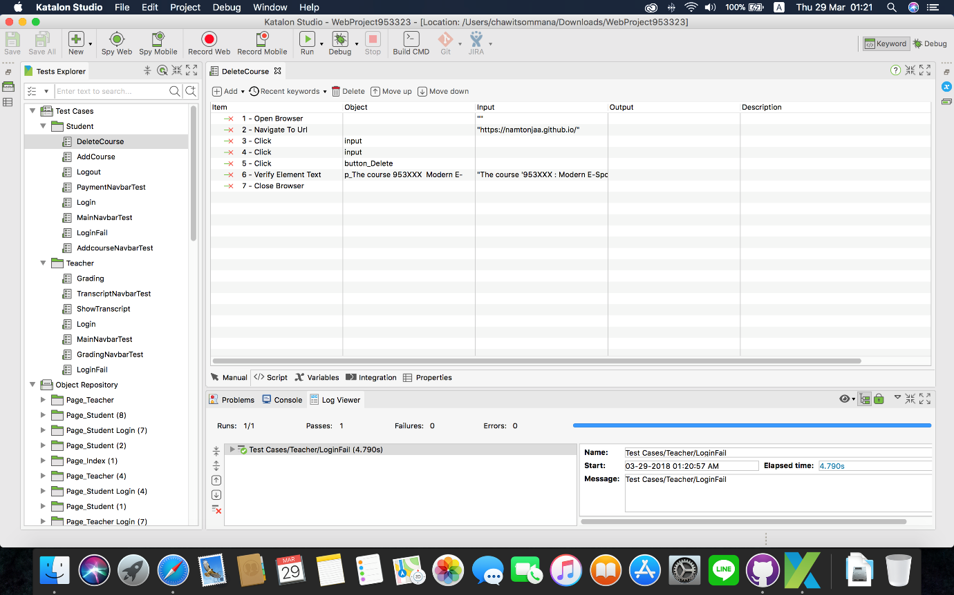

Test Script Feature 8 # Add course

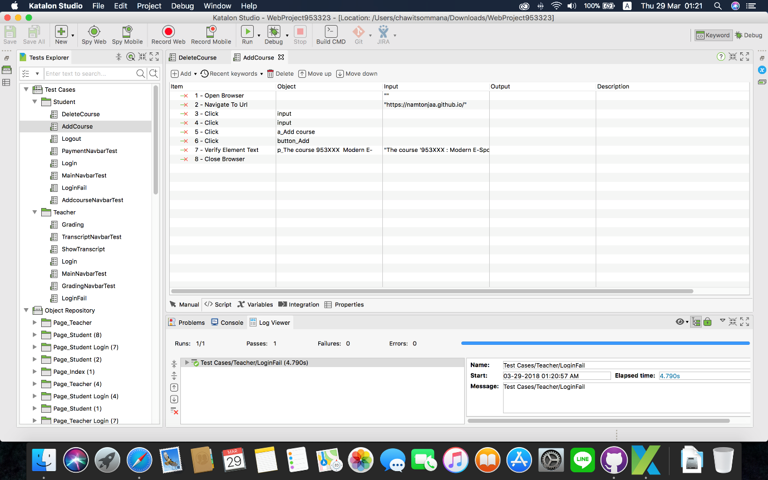

Test Script Feature 5 # Logout

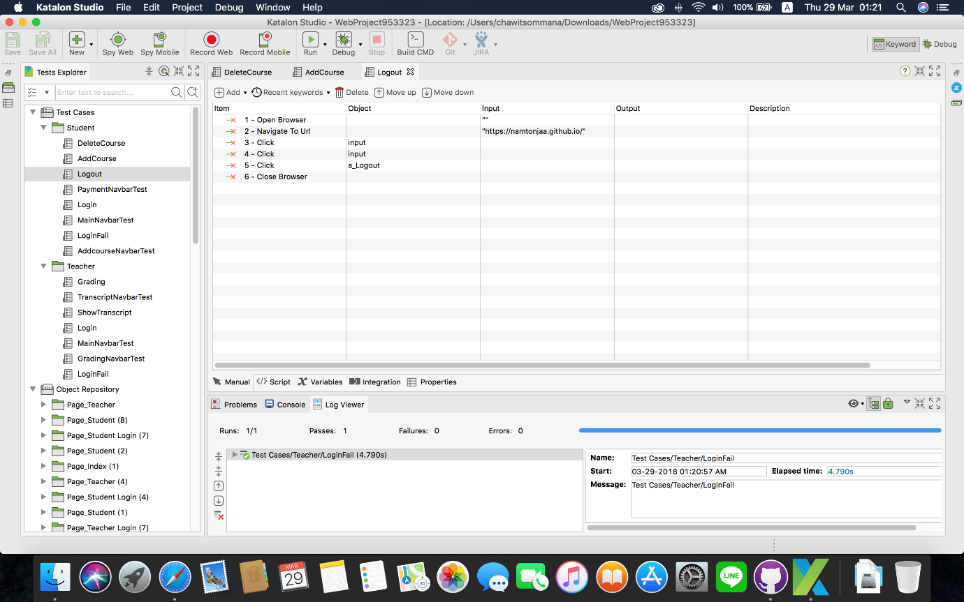

Test Script Feature 9 # Payment(Navbar)

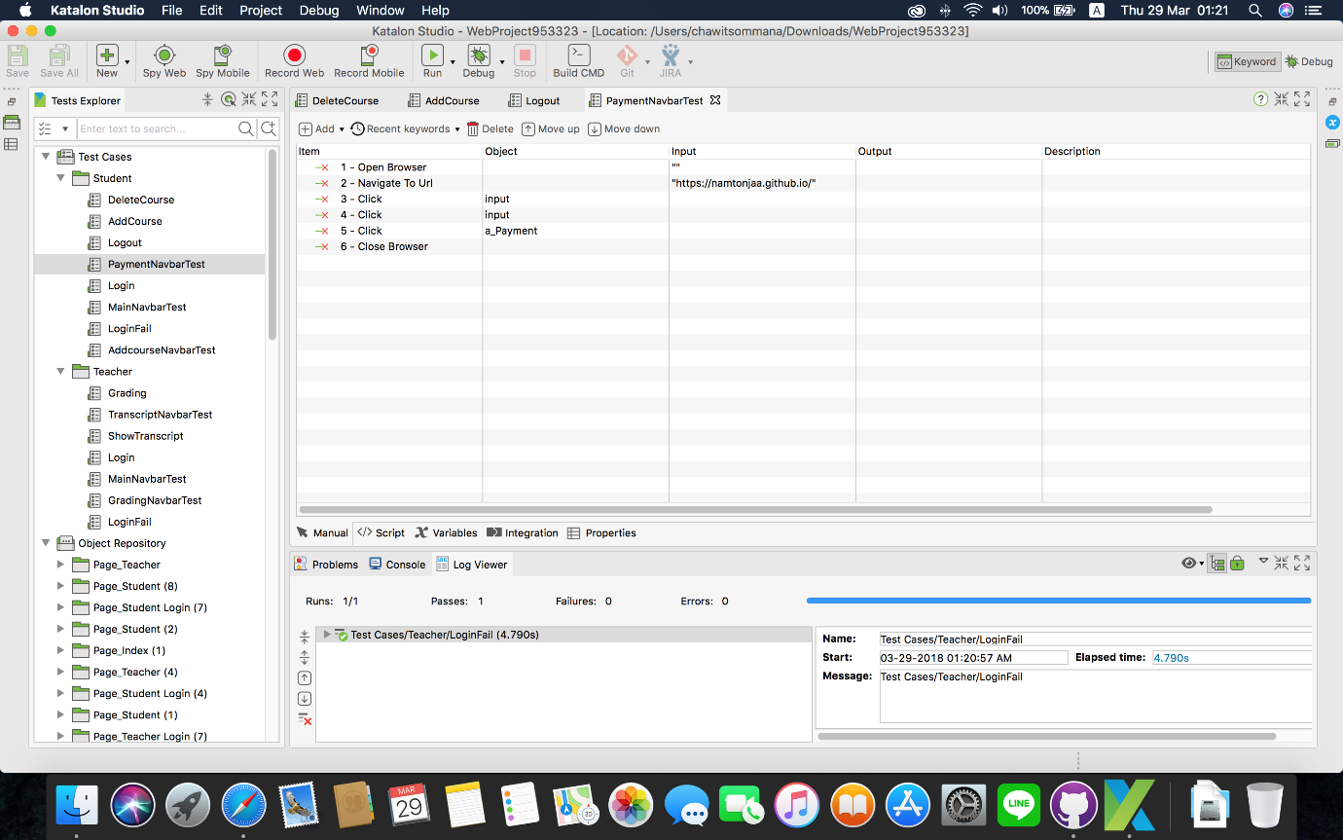

Test Script Feature # 1 Login page(Student)

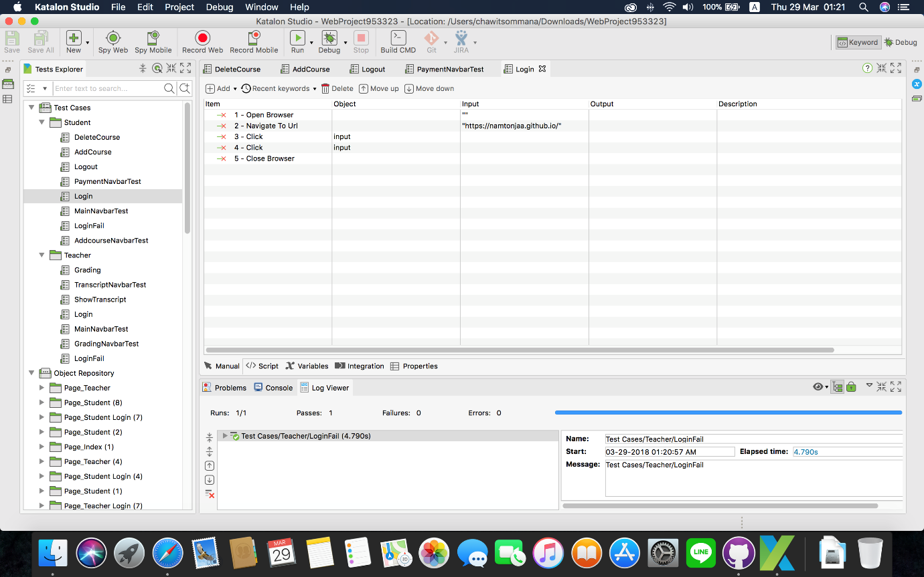

Test Script Feature 6 # List of Enrolled course of student (Main Navbar)

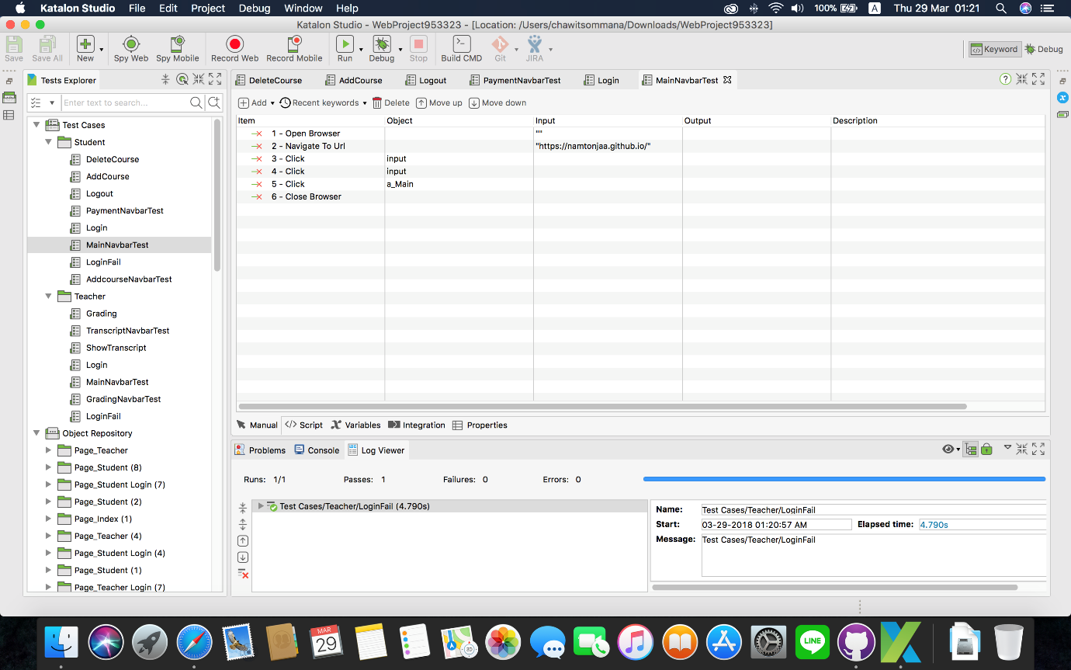

Test Script Feature#1 Login page(Fail)

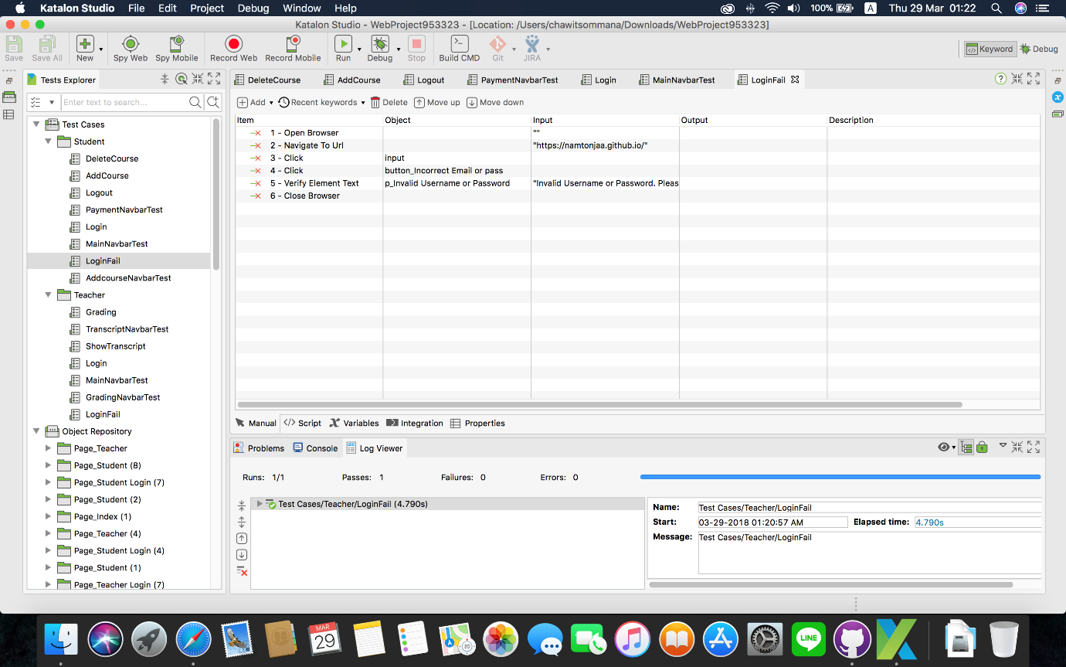

Test Script Feature 8 # Add course

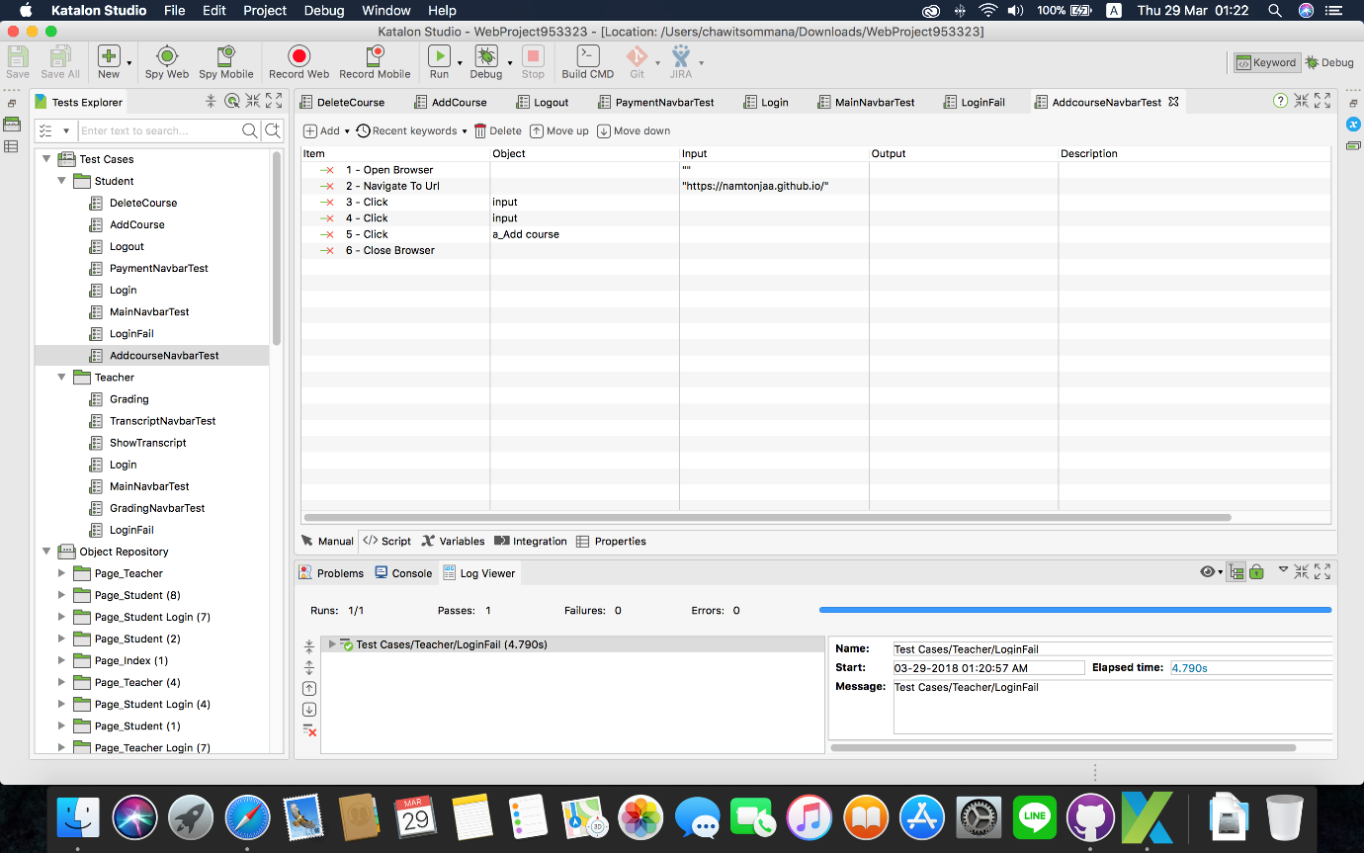

* Test Script the feature of teacher section

Test Script Feature#2 Grading system

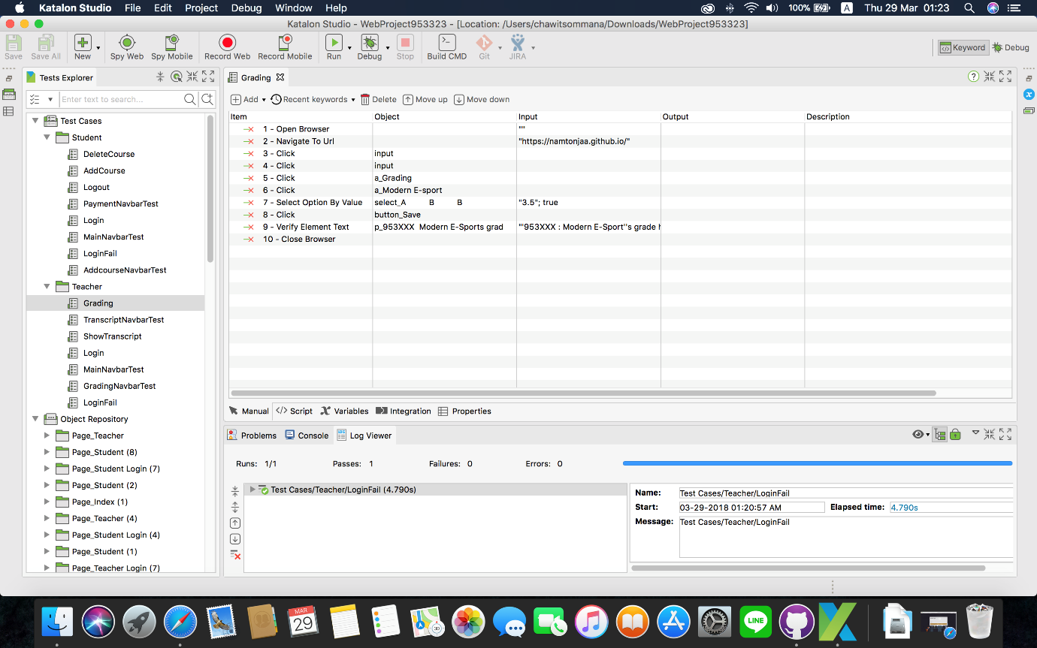

Test Script Feature # 4 Transcript(Navbar)

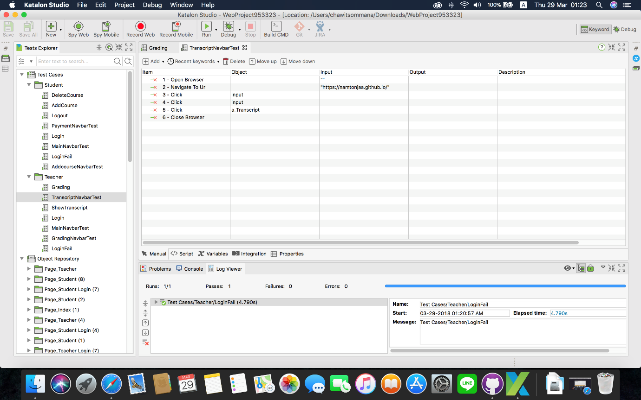

Test Script Feature # 4 Transcript (Show the transcript)

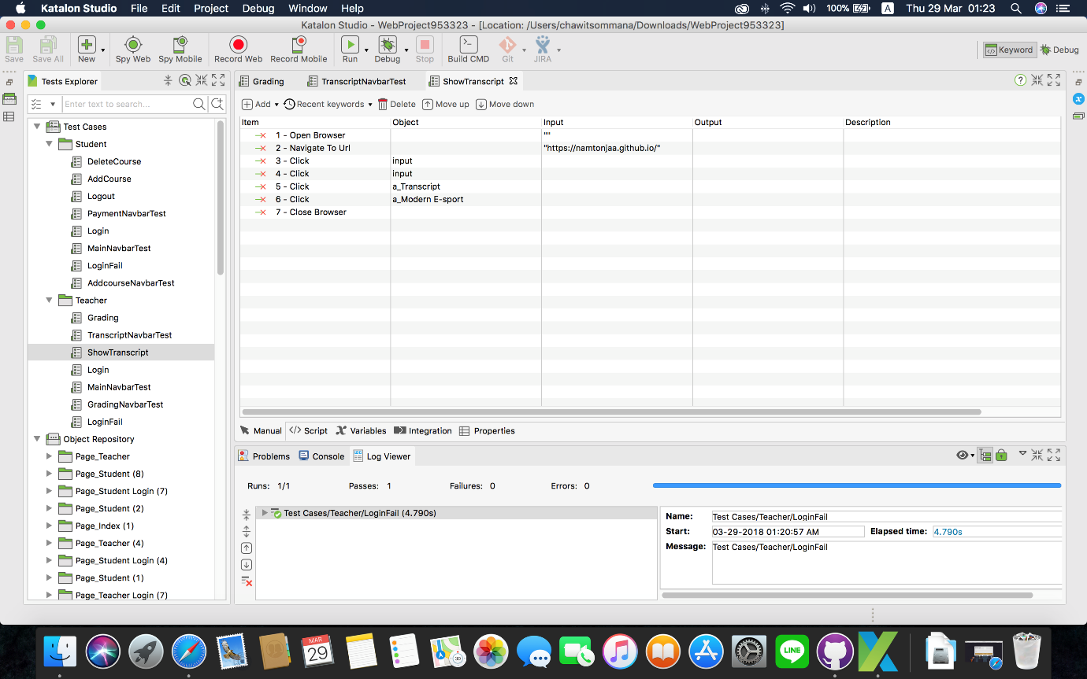

Test Script Feature # 1 Login page(Teacher)

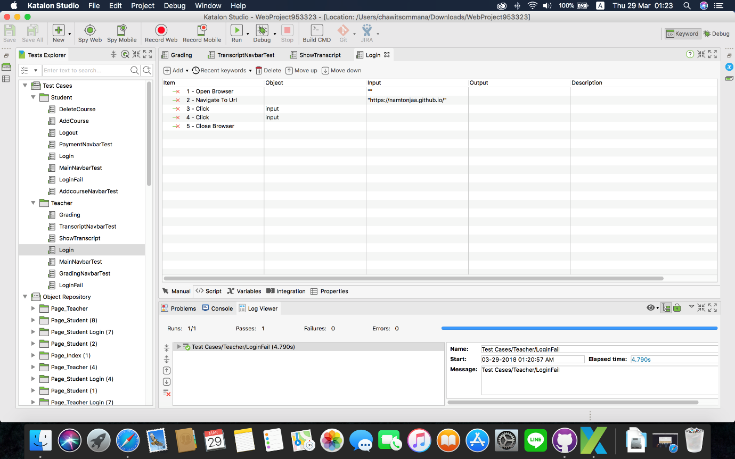

Test Script Feature # 3 Teaching course list (Main Navbar)

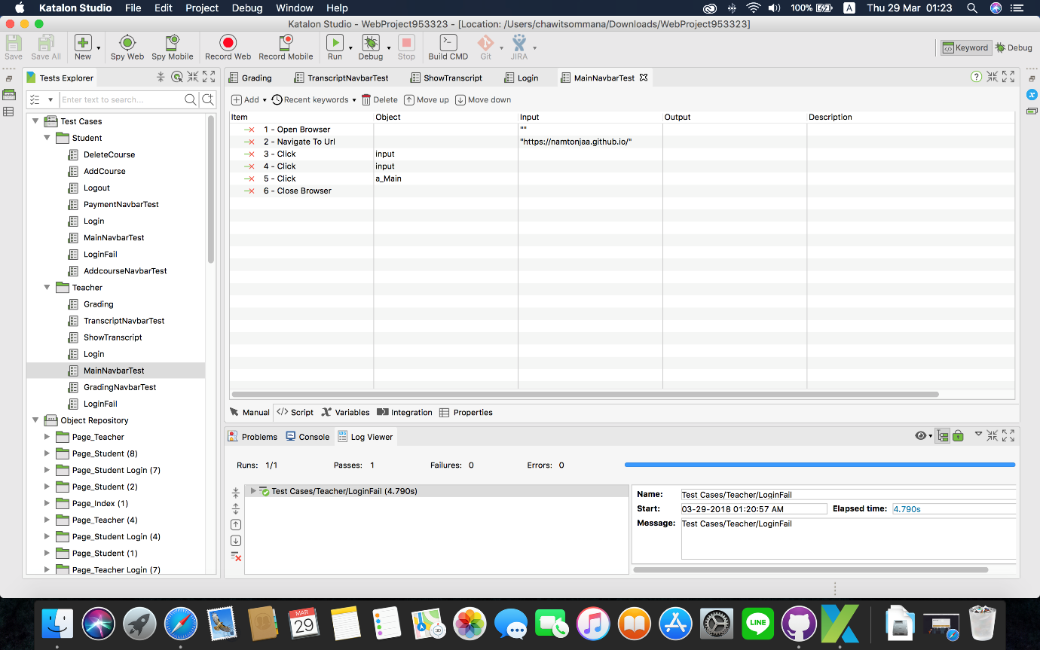

Feature # 2 Grading system(Navbar)

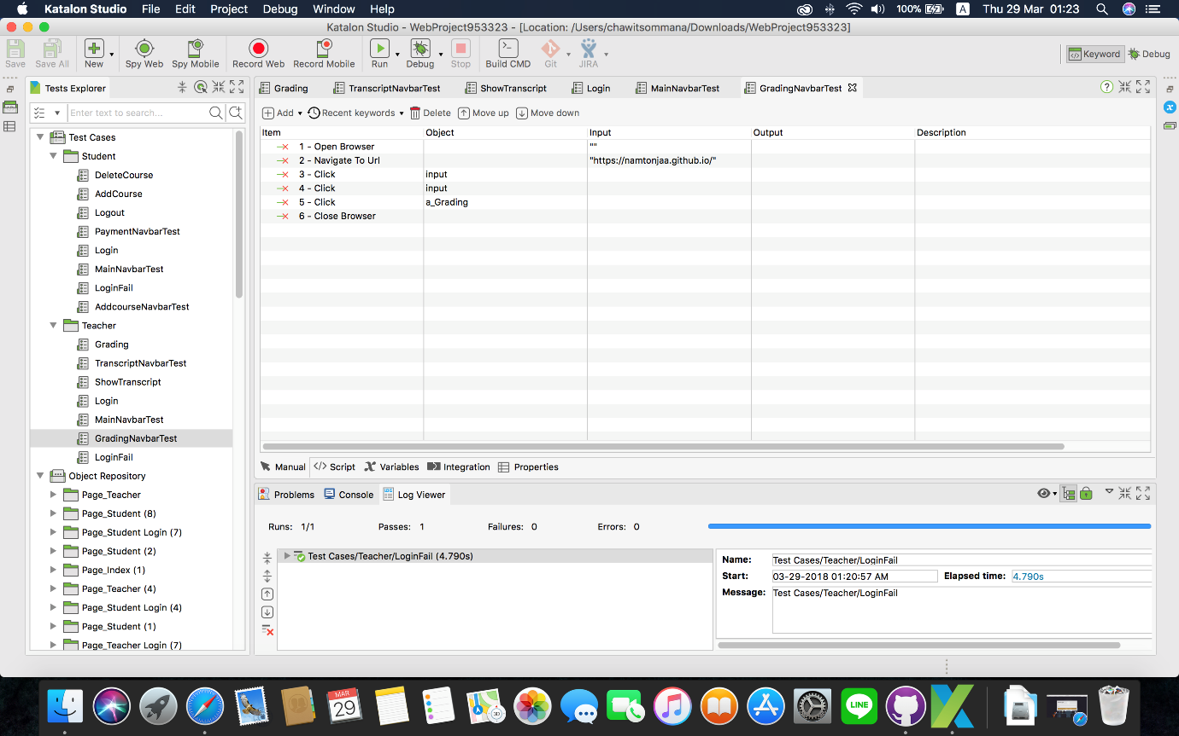

Test Script Feature#1 Login page(Fail)

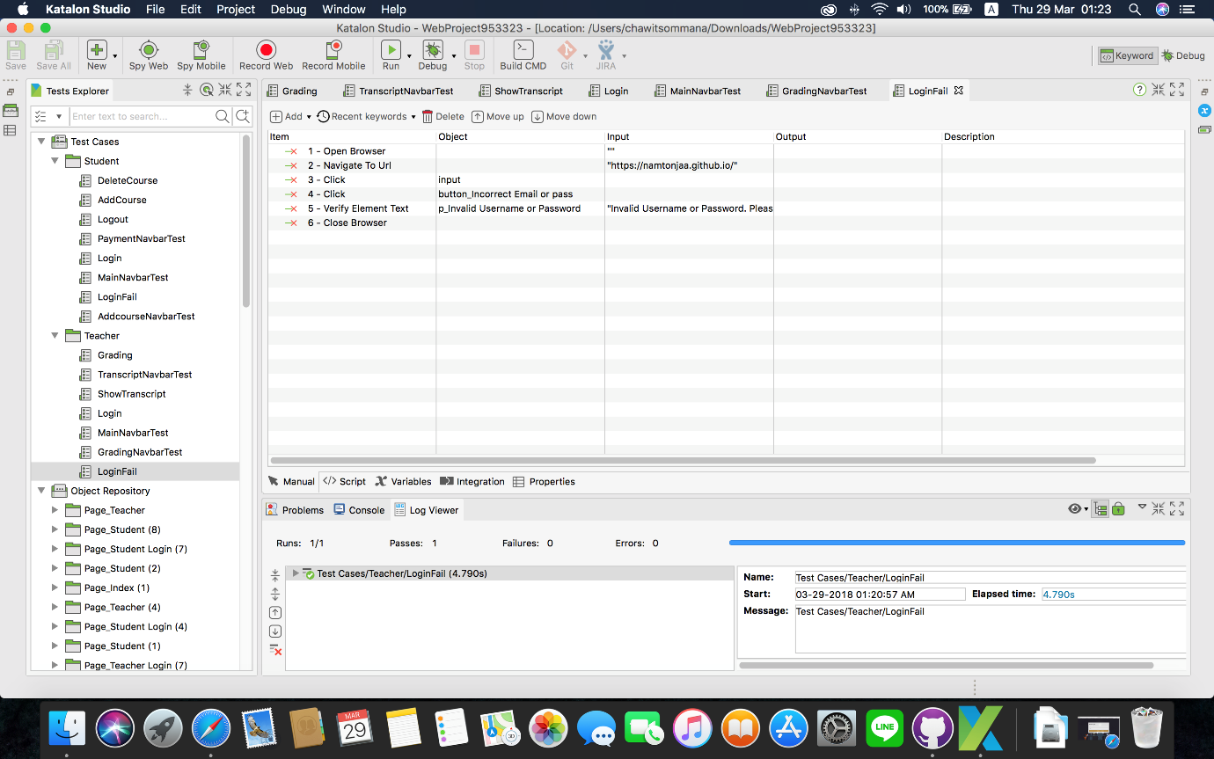

# Class Diagram